**All Aboard the Polar Express!**

**Please join us for our Polar Express Family Night.**

**We will have games, crafts and much much more.**

**Bring your holiday cheer and**

**climb aboard!**

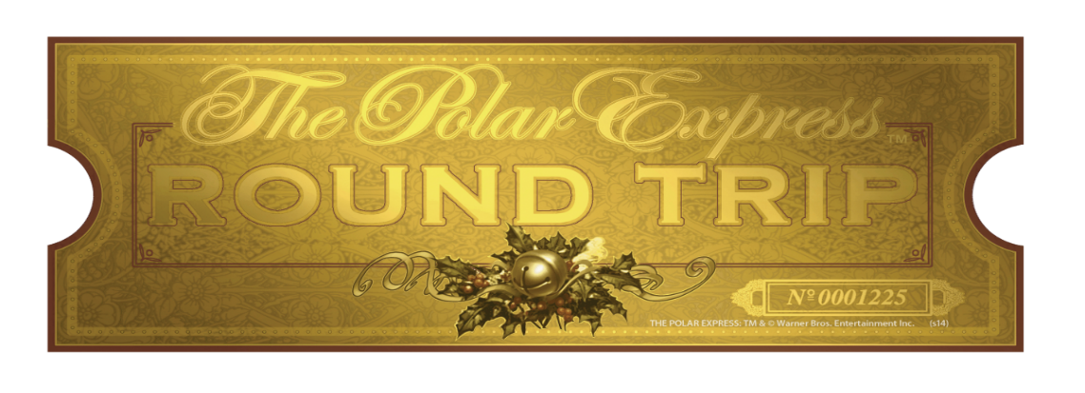

Family Night!

Date: Sat., December 16, 2017

Time: 6:00 pm - 7:30 pm

Place: McLouth Multi-Purpose Room

Be ready to board the Polar Express and take a

Mysterious ride to the North Pole!

** Children MUST be accompanied by an adult member.

C:\Users\raineya\AppData\Local\Microsoft\Windows\Temporary Internet Files\Content.IE5\F7OQ3FV1\MC900323014[1].wmf C:\Users\raineya\AppData\Local\Microsoft\Windows\Temporary Internet Files\Content.IE5\F7OQ3FV1\MC900323014[1].wmfC:\Users\raineya\AppData\Local\Microsoft\Windows\Temporary Internet Files\Content.IE5\F7OQ3FV1\MC900323014[1].wmfC:\Users\raineya\AppData\Local\Microsoft\Windows\Temporary Internet Files\Content.IE5\F7OQ3FV1\MC900323014[1].wmfC:\Users\raineya\AppData\Local\Microsoft\Windows\Temporary Internet Files\Content.IE5\F7OQ3FV1\MC900323014[1].wmf C:\Users\raineya\AppData\Local\Microsoft\Windows\Temporary Internet Files\Content.IE5\F7OQ3FV1\MC900323014[1].wmf C:\Users\raineya\AppData\Local\Microsoft\Windows\Temporary Internet Files\Content.IE5\F7OQ3FV1\MC900323014[1].wmf

**All Aboard the Polar Express!**

**Please return one RSVP form per family by**

**Thursday, November 30th.**

**Student (s) name: ____________________**

**____________________**

**____________________**

**Number of adults attending: _________**

**Total attending: __________**

**All Aboard the Polar Express!**

**Please return one RSVP form per family by**

**Thursday, November 30th.**

**Student (s) name: ____________________**

**____________________**

**____________________**

**Number of adults attending: _________**

**Total attending: __________**